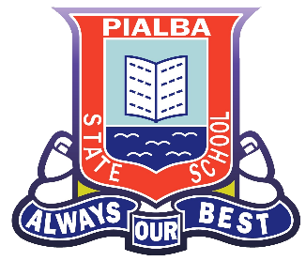
Gifted & Talented FAQs

What is the gifted program at Pialba State School?
At Pialba, we have a “whole school Inclusion Framework” in which Gifted & Talented education for students is enacted within this framework.
This means we acknowledge gifted students have specific needs that require a consistent, school-wide response. Our learning community recognises that gifted students aren’t all the same and consequently offers flexible approaches for students to experience learning and develop their natural abilities. The overview gives a snapshot of provision at Pialba.

The program is not a separate “add on’ or “withdrawal’’ approach, but is integral to the everyday workings of the classroom.

Teachers receive professional development and supported from the Head of Inclusion and Head of Department (Curriculum) that enables them to provide a learning environment where giftedness can be recognised and responded to. Professional development sessions focus on developing a shared understanding of giftedness, how to identify the gifted and ways to respond to the needs of gifted students.

How are students chosen for the program?
Students are not ‘chosen’ for a separate program because catering for gifted students is part of the everyday proceedings of the classroom. Giftedness is recognised as developmental and hence the nature of the environment provided is crucial to the recognition and development of abilities.
All students are treated as potentially gifted and through the provision of a responsive and enriched learning environment; teachers are able to observe special abilities and gifted behaviours. Once recognised, these abilities or traits are responded to with appropriate programs and instructional strategies.

