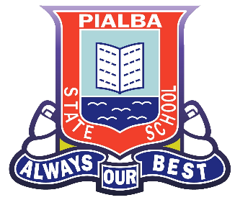
Pialba Parent and Citizens Association
Volunteer Policy
A volunteer is someone who gives their time, talent, energy and expertise freely without charge in a productive way to enhance and enrich our school community. They may be relatives of students or people who have responded to a request. They work for the best outcomes for the children of Pialba State School.

Philosophy
- We believe that volunteers are invaluable to our school but need to be supported by sound policies, procedures and planning in order to meet our objectives Interaction between volunteers and our school enhance our role within the local community.
- We believe that without volunteers, our ability to deliver an effective education to our students would be disrupted.
At our school:
Volunteers may help by
- Helping teachers in your child’s classroom – listening to students read, changing home readers and more
- Tuckshop duties – once a week, once a month or once every 3 months – it’s up to you!
- P&C fundraising activities – Discos, Pie drives, Mothers and Father’s day stalls, BBQ’s and more
- Volunteering to become part of the P&C
- Helping in the Library

Skills – all you need is smile, a willing helping hand and interest in our children’s education!!

Volunteer Contact Persons:
President: Ms Jacquie Rochester
Tuckshop Convenor – Mrs Stacey Doo
Principal – Mrs Janeen Fricke
Deputy Principal: Mr Peter Genrich

Email: admin@pialbass.eq.edu.au

